Project Paper: EDZ Data-Driven Operational Transformation
Target Organization: Électricité de Zahle (EDZ)
Project Lead: Mostapha Kayyar
Focus: Business Intelligence, Data Modeling, and Workforce Optimization

1. Executive Summary
This project aims to modernize the decision-making process for EDZ by transitioning from traditional reporting to an integrated Data-Driven Ecosystem. By centralizing data from customers, meters, grid operations, and field staff, we will create a "Single Source of Truth" to optimize revenue, reduce energy theft, and maximize employee productivity in the Zahle region.

2. Business Inquiries & Problem Statements
A. Revenue & Financial Integrity
- The Collection Gap: Why is there a discrepancy between the amount of electricity "Sent" from generators and the amount "Invoiced" to customers?
- Currency Volatility: How does the fluctuating LBP/USD exchange rate impact the profitability of fuel purchases versus local LBP collections?
- Arrears Management: Which customer segments (Residential vs. Industrial) represent the highest financial risk due to non-payment?
B. Grid & Technical Operations
- Non-Technical Loss (NTL): In which specific geographical sectors is energy "leakage" (theft or faulty meters) highest?
- Load Forecasting: Can we predict peak demand hours to optimize diesel generator usage and reduce unnecessary fuel burn?
C. Workforce & Field Performance (The "Backbone" Support)
- Collector Efficiency: Which bill collectors are meeting their monthly targets, and who has the highest "Strike Rate" (successful collections per visit)?
- Reading Authenticity: Are meter readers actually visiting the physical sites, or are they "estimating" readings?
- Route Optimization: Are the geographical zones assigned to staff balanced fairly based on the density of meters and travel time?

3. Proposed Solution: The "EDZ Data Engine"
To solve these problems, the project will implement a three-tier architecture:
- Relational Data Modeling (MySQL): A robust Star-Schema database to link disparate data points (Staff ID, Customer ID, Meter Reading, and Payment Status).
- Synthetic Trend Generation: Creation of a 24-month high-fidelity dataset that simulates real-world Lebanese challenges (seasonality, fuel price spikes, and collection delays).
- Strategic Visualization (Power BI): Interactive dashboards designed for department heads to monitor KPIs in real-time.

4. Key Performance Indicators (KPIs)
Category | KPI Name | Definition/Goal
Financial | Collection Rate % | (Total Cash Collected / Total Amount Billed). Target: >98%.
Operations | Line Loss Ratio | (Energy Supplied - Energy Metered) / Energy Supplied.
Staff | Visit Velocity | Average time taken per meter reading/collection visit.
Staff | Accuracy Index | % of readings confirmed via GPS/Photo vs. Manual entry.
Market | Consumption Trend | KWh usage per neighborhood to identify growth areas.

5. Technical Workflow & Documentation
To ensure professional delivery, the project will follow these documentation standards:
- Conceptual Modeling: Entity Relationship Diagram (ERD) using Draw.io.
- Data Dictionary: Full definition of table schemas and data types.
- DAX Library: Documentation of complex Power BI measures (e.g., Year-over-Year Growth, Rolling Averages).

6. Business Impact
By completing this project, EDZ will gain the ability to:
- Identify and eliminate illegal connections in specific sectors.
- Reward high-performing staff based on objective data rather than intuition.
- Protect profit margins by aligning fuel procurement with actual consumption patterns.

Sketch & Relationship Plan
1. Data Tables Sketch (The Entities) - The Relationships
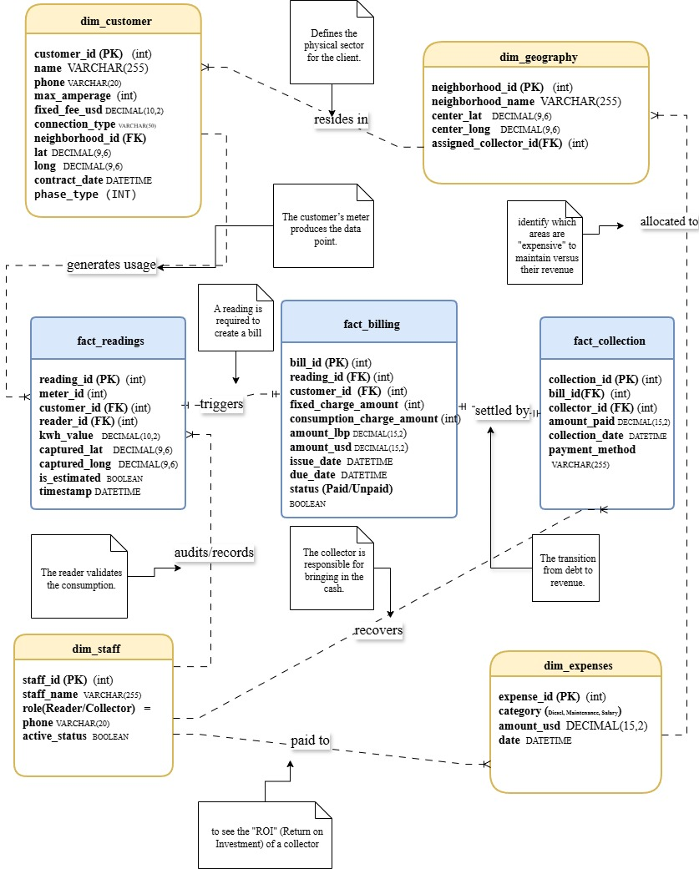
2. Visual Sketch for Draw.io
"Star Schema" inspired layout:
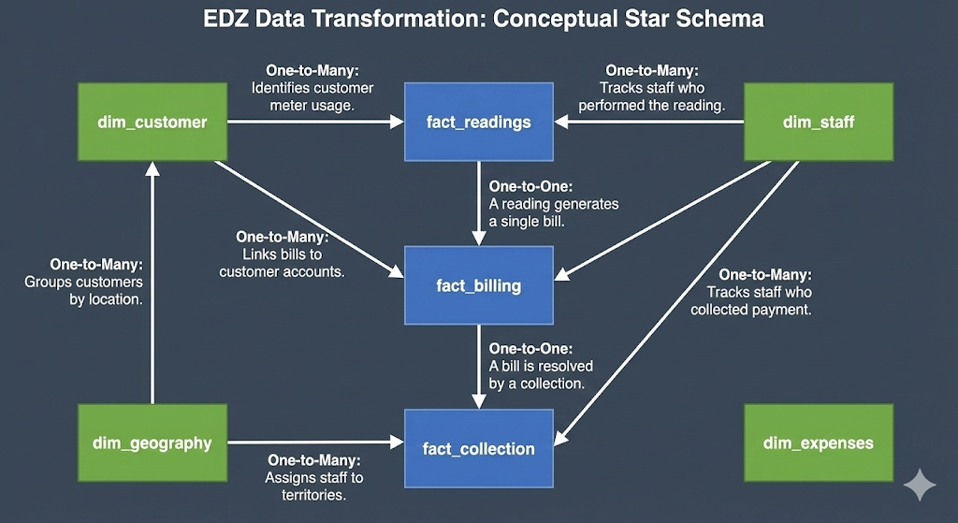

1. Dimension Tables (The "Who, Where, and What")
dim_customer (Customer Master File)
- customer_id [PK] (INT)
- name (VARCHAR): Customer Full Name.
- phone (VARCHAR): For SMS alerts/billing reminders.
- max_amperage (INT): Contracted power (e.g., 15A, 30A).
- fixed_fee_usd (DECIMAL): Monthly cost based on amperage.
- phase_type (INT): 1 for Single-Phase, 3 for Three-Phase.
- connection_type (VARCHAR): Residential, Commercial, or Industrial.
- neighborhood_id [FK]: Links to dim_geography.
- lat / long (DECIMAL): Home GPS coordinates for audit.
- contract_date (DATETIME)
- is_active (BOOLEAN): Tracks churn/status.
dim_staff (Employee Registry)
- staff_id [PK] (INT)
- staff_name (VARCHAR)
- role (VARCHAR): Reader, Collector, or Technician.
- phone_number (VARCHAR)
- active_status (BOOLEAN)
dim_geography (Area Mapping)
- neighborhood_id [PK] (INT)
- neighborhood_name (VARCHAR): e.g., Houch El Omara, Midane.
- center_lat / long (DECIMAL): Map center points for the zone.
- assigned_collector_id [FK]: Links to dim_staff.
dim_expenses (Financial Reference)
- expense_id [PK] (INT)
- category (VARCHAR): Diesel, Maintenance, Salary.
- amount_usd (DECIMAL)
- date (DATETIME)

2. Fact Tables (The "Numbers and Actions")
fact_readings (Meter Reading Events)
- reading_id [PK] (INT)
- meter_id (INT)
- customer_id [FK] (INT)
- reader_id [FK]: Links to dim_staff.
- kwh_value (DECIMAL): The energy consumed (Current Index - Previous Index).
- captured_lat / long (DECIMAL): GPS location of staff at time of reading.
- is_estimated (BOOLEAN): 1 for estimated, 0 for actual.
- timestamp (DATETIME)
fact_billing (Invoicing Data)
- bill_id [PK] (INT)
- reading_id [FK] (INT)
- customer_id [FK] (INT): Denormalized for faster Power BI filtering.
- fixed_charge_amount (DECIMAL): Revenue from Amperage.
- consumption_charge_amount (DECIMAL): Revenue from kWh usage.
- amount_lbp / amount_usd (DECIMAL): Total bill in both currencies.
- issue_date / due_date (DATETIME)
- status (VARCHAR): Paid, Unpaid, or Partial.
fact_collection (Cash Flow)
- collection_id [PK] (INT)
- bill_id [FK] (INT)
- collector_id [FK]: Links to dim_staff.
- amount_paid (DECIMAL)
- collection_date (DATETIME)
- payment_method (VARCHAR): Cash, OMT, Bank.

3. Updated Core Relationships (The Verb Phrases)
- Resides In: dim_geography (1) → (N) dim_customer. Defines the physical sector.
- Generates Usage: dim_customer (1) → (N) fact_readings. The meter produces the data point.
- Audits/Records: dim_staff (1) → (N) fact_readings. The Reader validates consumption.
- Triggers: fact_readings (1) → (1) fact_billing. A reading is required to create a bill.
- Settled By: fact_billing (1) → (N) fact_collection. The transition from debt to revenue.
- Recovers: dim_staff (1) → (N) fact_collection. The Collector brings in the cash.
- Incurs/Paid To: dim_staff (1) → (N) dim_expenses. To see the "ROI" of an employee.
- Allocated To: dim_geography (1) → (N) dim_expenses. To identify "expensive" maintenance zones.

